Lab 17 : Streaming Data into Iceberg with Redpanda

Table of Contents
Table of Contents 2
Introduction 3
Learning Objectives 3
Prerequisites 3
Part 1 — Create the Source Topic & Data 4
Step 1 — Create the Topic 4
Step 2 — Create the .env Credentials File 4
Step 3 — Produce Streaming Data 4
Part 2 — Write the PySpark Streaming Job 6
Architecture Breakdown 8
Part 3 — Execute the Streaming Pipeline 8
Part 4 — Verify the Iceberg Table 9
Knowledge Check 12
Troubleshooting 12
Symptom: java.lang.IllegalArgumentException: requirement failed: Unrecognized sasl.mechanism 12
Symptom: Job hangs and never writes data. 12
Next Steps 13
Conclusion 13

Introduction
In modern data architectures, the "Streaming Lakehouse" is replacing the traditional batch-loaded Data Warehouse. Instead of dumping raw files into an S3 bucket and running nightly ETL jobs, data teams use Redpanda to stream events directly into Apache Iceberg tables in near real-time.
In this lab, you will build a robust streaming ingestion pipeline. You will use Apache Spark Structured Streaming to continuously consume JSON events from a Redpanda Serverless topic, enforce a strict schema, and write the stream directly into a local Apache Iceberg table.

Learning Objectives
Upon completing this lab, you will be able to:
- Configure PySpark to consume from a secure Redpanda Cloud cluster.
- Parse streaming JSON payloads using Spark DataFrames.
- Write a continuous stream of data into an Apache Iceberg table using append mode.
- Understand Spark checkpointing for streaming reliability.

Prerequisites
- rpk installed and authenticated to Redpanda Cloud.
- A Redpanda Cloud account (Serverless tier).
- Your Serverless Bootstrap Server URL, Username, and Password.
- Python 3 and Java (JRE) installed on your VM.
Ensure your virtual environment is active and python-dotenv is installed:
mkdir ~/iceberg-labs
cd ~/iceberg-labs
pip3 install pyspark python-dotenv

Part 1 — Create the Source Topic & Data
First, we need a stream of data in Redpanda Cloud.

Step 1 — Create the Topic
rpk topic create lakehouse-events

Step 2 — Create the .env Credentials File
If you don't already have one in this directory, create a .env file to securely store your cloud credentials:
.env

Paste and populate:
REDPANDA_BROKERS="YOUR_BOOTSTRAP_SERVER_URL:9092"
REDPANDA_USER="your_username"
REDPANDA_PASS="your_password"

(Save and exit).

Step 3 — Produce Streaming Data
Open a second terminal window to act as our live data producer. We will use a bash loop to simulate a continuous stream of user click events every 2 seconds.
while true; do
TIMESTAMP=$(date -u +"%Y-%m-%dT%H:%M:%SZ")
USER_ID=$((RANDOM % 100 + 1))
echo "{\"user_id\": $USER_ID, \"event\": \"click\", \"event_time\": \"$TIMESTAMP\"}" | rpk topic produce lakehouse-events
sleep 2
done
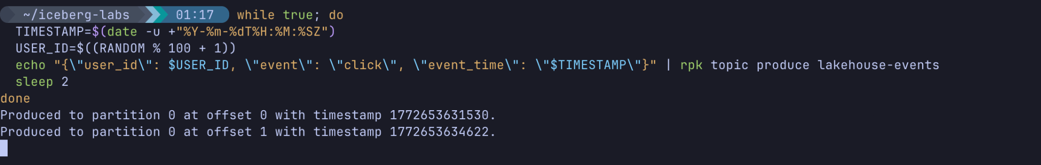
(Leave this running in the background!)

Part 2 — Write the PySpark Streaming Job
Return to your first terminal window. We will write a PySpark Structured Streaming application.
Create the script:
stream_to_iceberg.py

Paste the following code:
import os
from pyspark.sql import SparkSession
from pyspark.sql.functions import from_json, col
from pyspark.sql.types import StructType, StructField, IntegerType, StringType, TimestampType
from dotenv import load_dotenv
load_dotenv()
BROKER_URL = os.getenv("REDPANDA_BROKERS")
USERNAME = os.getenv("REDPANDA_USER")
PASSWORD = os.getenv("REDPANDA_PASS")
TOPIC = "lakehouse-events"
print("Initializing Spark Streaming Session...")
# We must include both the Iceberg runtime AND the Spark-Kafka integration packages
spark = SparkSession.builder \
.appName("RedpandaToIceberg") \
.config("spark.jars.packages", "org.apache.iceberg:iceberg-spark-runtime-3.5_2.12:1.5.0,org.apache.spark:spark-sql-kafka-0-10_2.12:3.5.0") \
.config("spark.sql.extensions", "org.apache.iceberg.spark.extensions.IcebergSparkSessionExtensions") \
.config("spark.sql.catalog.local", "org.apache.iceberg.spark.SparkCatalog") \
.config("spark.sql.catalog.local.type", "hadoop") \
.config("spark.sql.catalog.local.warehouse", f"{os.getcwd()}/warehouse") \
.getOrCreate()
# 1. Define the Schema for the incoming JSON
schema = StructType([
StructField("user_id", IntegerType(), True),
StructField("event", StringType(), True),
StructField("event_time", TimestampType(), True)
])
# 2. Configure the Kafka Source (Redpanda Cloud requires SASL_SSL)
print(f"Connecting to Redpanda Topic: {TOPIC}...")
kafka_df = spark.readStream \
.format("kafka") \
.option("kafka.bootstrap.servers", BROKER_URL) \
.option("subscribe", TOPIC) \
.option("startingOffsets", "earliest") \
.option("kafka.security.protocol", "SASL_SSL") \
.option("kafka.sasl.mechanism", "SCRAM-SHA-256") \
.option("kafka.sasl.jaas.config", f'org.apache.kafka.common.security.scram.ScramLoginModule required username="{USERNAME}" password="{PASSWORD}";') \
.load()
# 3. Parse the raw Kafka bytes into Structured Columns
parsed_df = kafka_df.selectExpr("CAST(value AS STRING)") \
.select(from_json(col("value"), schema).alias("data")) \
.select("data.*")
# 4. Create the target Iceberg table (if it doesn't exist)
spark.sql("""
CREATE TABLE IF NOT EXISTS local.db.lakehouse_events (
user_id INT,
event STRING,
event_time TIMESTAMP
)
USING iceberg
""")
# 5. Write the Stream to Iceberg
print("Starting stream to Iceberg table 'local.db.lakehouse_events'...")
query = parsed_df.writeStream \
.format("iceberg") \
.outputMode("append") \
.option("path", "local.db.lakehouse_events") \
.option("checkpointLocation", f"{os.getcwd()}/warehouse/checkpoints/lakehouse_events") \
.trigger(processingTime="5 seconds") \
.start()
query.awaitTermination()

(Save and exit).

Architecture Breakdown
- spark-sql-kafka-0-10: We dynamically download the Kafka connector for Spark so it can talk to Redpanda.
- SASL_SSL / JAAS: Because Redpanda Cloud is secure over the internet, we must inject our credentials into the Java Authentication and Authorization Service (JAAS) config string so Spark can authenticate.
- checkpointLocation: Crucial for exactly-once semantics. Spark saves its exact Kafka offset position here. If the streaming job crashes, it reads the checkpoint to resume exactly where it left off without duplicating data.
- trigger(processingTime="5 seconds"): Instead of writing a file for every single message, Spark batches the incoming events every 5 seconds and writes a new Parquet file to Iceberg.

Part 3 — Execute the Streaming Pipeline
Run your Spark application:
python3 stream_to_iceberg.py

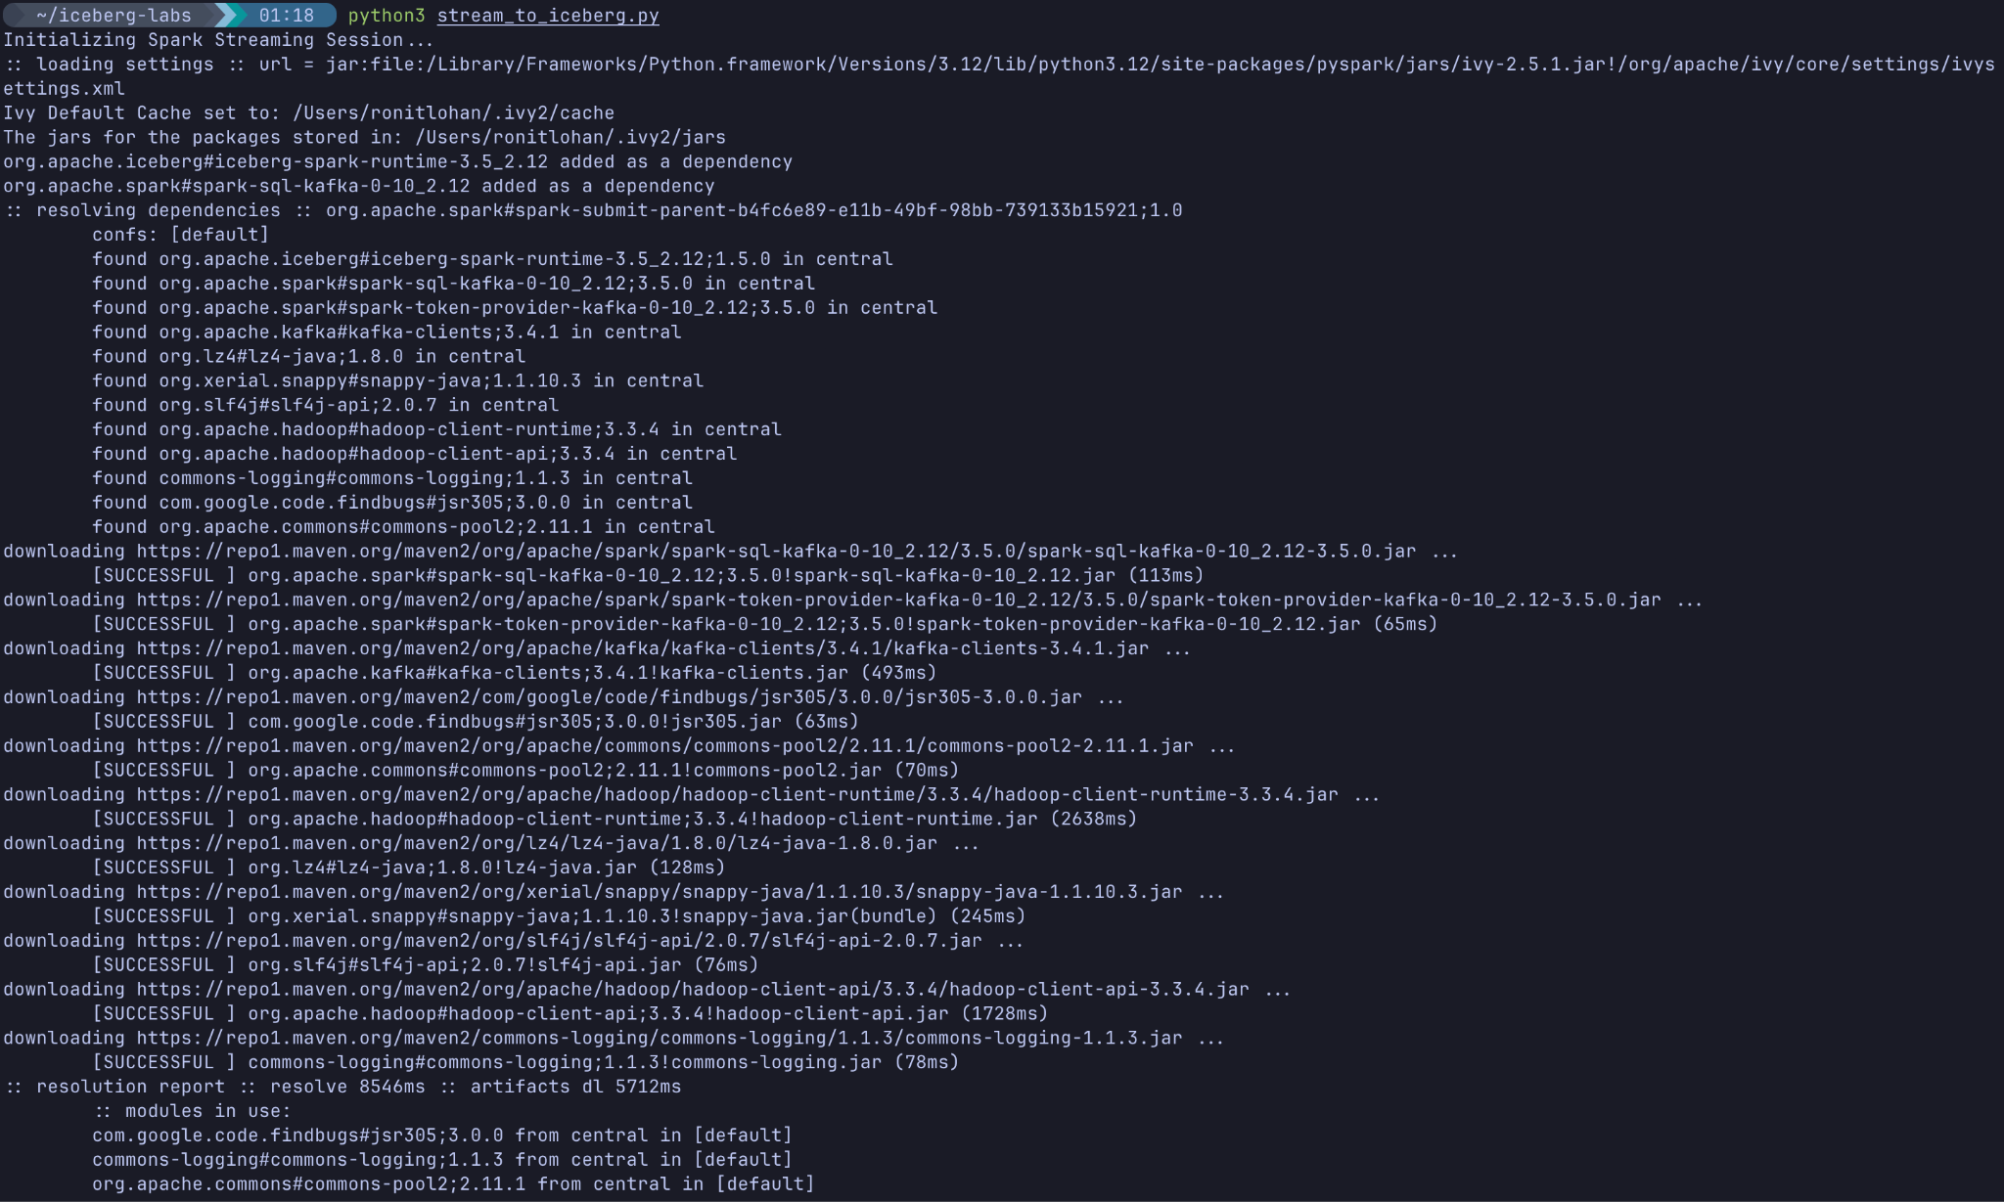
What you will see: Spark will initialize, output a lot of standard logging, and eventually print Starting stream to Iceberg table.... It will then quietly run in the background, flushing micro-batches of data into your Iceberg directory every 5 seconds.
Let this run for about 30 to 45 seconds, then press Ctrl+C in your first terminal to stop the streaming job.
(You can also press Ctrl+C in your second terminal to stop the Redpanda producer loop).

Part 4 — Verify the Iceberg Table
Let's write a quick script to query our Iceberg table and ensure the real-time events actually landed.
Create verify_lakehouse.py:
verify_lakehouse.py

Paste:
from pyspark.sql import SparkSession
import os
spark = SparkSession.builder \
.appName("VerifyIceberg") \
.config("spark.jars.packages", "org.apache.iceberg:iceberg-spark-runtime-3.5_2.12:1.5.0") \
.config("spark.sql.extensions", "org.apache.iceberg.spark.extensions.IcebergSparkSessionExtensions") \
.config("spark.sql.catalog.local", "org.apache.iceberg.spark.SparkCatalog") \
.config("spark.sql.catalog.local.type", "hadoop") \
.config("spark.sql.catalog.local.warehouse", f"{os.getcwd()}/warehouse") \
.getOrCreate()
print("Querying local.db.lakehouse_events:")
spark.sql("SELECT * FROM local.db.lakehouse_events ORDER BY event_time DESC LIMIT 10").show()
spark.stop()

(Save and exit).
Run the verification query:
python3 verify_lakehouse.py

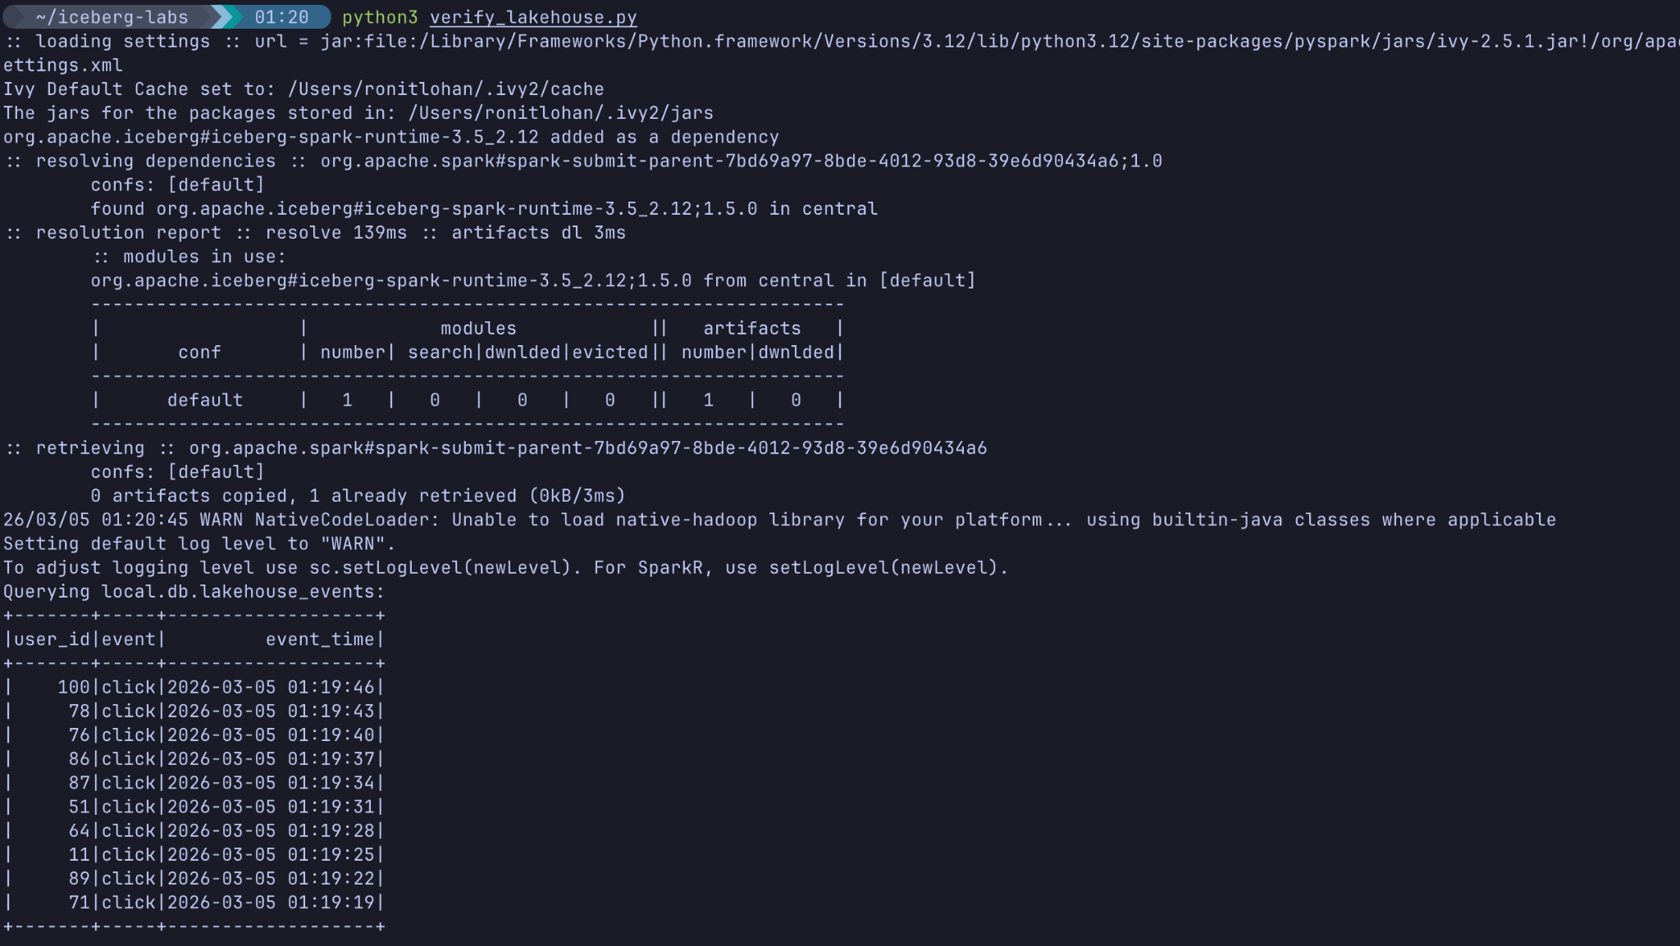
Expected Output: You will see the latest 10 click events with their generated timestamps successfully queryable via standard SQL!

